Identifiers & JavaBeans
Identifiers must start with a letter, a currency character ($), or a connecting
character such as the underscore ( _ ). Identifiers cannot start with a number!

In practice, there is no limit to the number of characters an identifier can
contain.

first some legal identifiers:
int _a;
int $c;
int ______2_w;
int _$;
int this_is_a_very_detailed_name_for_an_identifier;
The following are illegal (it's your job to recognize why):
int :b;
int -d;
int e#;
int .f;
int 7g;
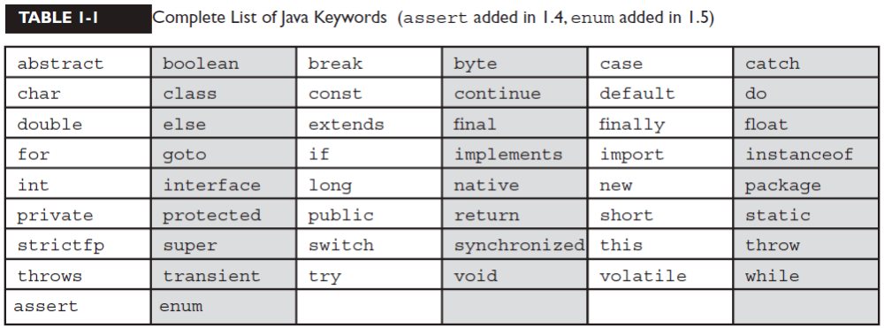
JavaBeans are Java classes that have properties
-java Beans
If the property is not a boolean, the getter method's prefix must be get. For
example, getSize()is a valid JavaBeans getter name for a property named
"size."

If the property is a boolean, the getter method's prefix is either get or is. For
example, getStopped() or isStopped() are both valid JavaBeans names for
a boolean property

The setter method's prefix must be set. For example, setSize() is the valid
JavaBean name for a property named size.
Examples of valid JavaBean method signatures are
public void setMyValue(int v)
public int getMyValue()
public boolean isMyStatus()
public void addMyListener(MyListener m)
public void removeMyListener(MyListener m)
Examples of invalid JavaBean method signatures are
void setCustomerName(String s) // must be public
public void modifyMyValue(int v) // can't use 'modify'
public void addXListener(MyListener m) // listener type mismatch

Class Declarations and Modifi ers

Access modifiers: public, protected, private.
■ Non-access modifiers (including strictfp, final, and abstract).
Default Access [package level]
package cert;
class Beverage
{

}

Now look at the second source file:
package exam.stuff;
import cert.Beverage;

class Tea extends Beverage
{
}

The Beverage file compiles fine, but when we
try to compile the Tea file we get something like:
Can't access class cert.Beverage. Class or interface must be
public, in same package, or an accessible member class.
Tea won't compile because its superclass, Beverage, has default access
You can do one of two things to make this work
You could put
both classes in the same package, or you could declare Beverage as public
Public Access
Universe (JU) have access to a public class
Don't forget, though, that if a public
class you're trying to use is in a different package from the class you're writing, you'll
still need to import the public class.

Other (Nonaccess) Class Modifiers

strictfp is a keyword and can be used to modify a class or a method, but never a
variable.

Final Classes
When used in a class declaration, the final keyword means
the class can't be subclassed
no other class can ever extend
and any attempts to do so will give you a compiler error.
You'll notice many classes in the Java core libraries are final. For example, the
String class cannot be subclassed.

package cert;
public final class Beverage {
public void importantMethod() { }
}
Now, if we try to compile the Tea subclass:
package exam.stuff;
import cert.Beverage;
class Tea extends Beverage { }
We get an error something like
Can't subclass final classes: class
cert.Beverage class Tea extends Beverage{
1 error

Abstract Classes
An abstract class can never be instantiated
abstract class Car
{
private double price;
private String model;
private String year;
public abstract void goFast();
public abstract void goUpHill();
public abstract void impressNeighbors();
// Additional, important, and serious code goes here
}

The preceding code will compile fine. However, if you try to instantiate a Car in
another body of code, you'll get a compiler error something like this:
AnotherClass.java:7: class Car is an abstract
class. It can't be instantiated.
Car x = new Car();

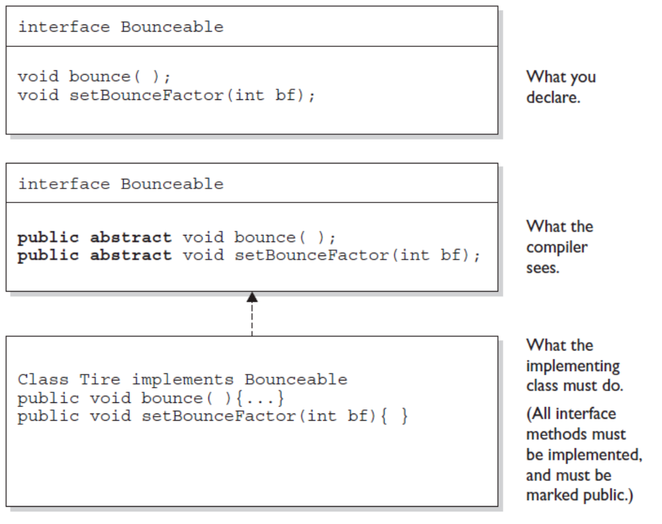
All interface methods are implicitly public and abstract. In other words,
you do not need to actually type the public or abstract modifiers in the
method declaration, but the method is still always public and abstract.

■ All variables defined in an interface must be public, static, and final—
in other words, interfaces can declare only constants, not instance variables.

Interface methods must not be static.
■ Because interface methods are abstract, they cannot be marked final,
strictfp, or native. (More on these modifiers later.)
■ An interface can extend one or more other interfaces.
■ An interface cannot extend anything but another interface.
■ An interface cannot implement another interface or class.
■ An interface must be declared with the keyword interface.
■ Interface types can be used polymorphically

legal interface declaration:
public abstract interface Rollable { }
Typing in the abstract modifier is considered redundant; interfaces are
implicitly abstract whether you type abstract or not

public abstract interface Rollable { }
public interface Rollable { }

METHODS
public interface Bounceable
{
public abstract void bounce();
public abstract void setBounceFactor(int bf);
}

following code is exactly equivalent to the
preceding interface:
public interface Bounceable {
void bounce(); // No modifiers
void setBounceFactor(int bf); // No modifiers
}

VALID
void bounce();
public void bounce();
abstract void bounce();
public abstract void bounce();
abstract public void bounce();

The following interface method declarations won't compile:
final void bounce(); // final and abstract can never be used
// together, and abstract is implied
static void bounce(); // interfaces define instance methods
private void bounce(); // interface methods are always public
protected void bounce(); // (same as above)

Declaring Interface Constants
You need to remember one key rule for interface constants. They must always be

public static final

interface Foo
{
int BAR = 42;
void go();
}
class Zap implements Foo
{
public void go()
{
BAR = 27;
}
}
You can't change the value of a constant! Once the value has been assigned, the
value can never be modified

So the BAR = 27 assignment will not compile.
VALID
public int x = 1; // Looks non-static and non-final,
// but isn't!
int x = 1; // Looks default, non-final,
// non-static, but isn't!
static int x = 1; // Doesn't show final or public
final int x = 1; // Doesn't show static or public
public static int x = 1; // Doesn't show final
public final int x = 1; // Doesn't show static
static final int x = 1 // Doesn't show public
public static final int x = 1; // what you get implicitly

Access Modifiers
public
■ protected
■ default
■ private

Whether method code in one class can access a member of another class
■ Whether a subclass can inherit a member of its superclass

example:
class Zoo {
public String coolMethod() {
return "Wow baby";
}
}
class Moo {
public void useAZoo() {
Zoo z = new Zoo();
// If the preceding line compiles Moo has access
// to the Zoo class
// But... does it have access to the coolMethod()?
System.out.println("A Zoo says, " + z.coolMethod());
// The preceding line works because Moo can access the
// public method
}
}

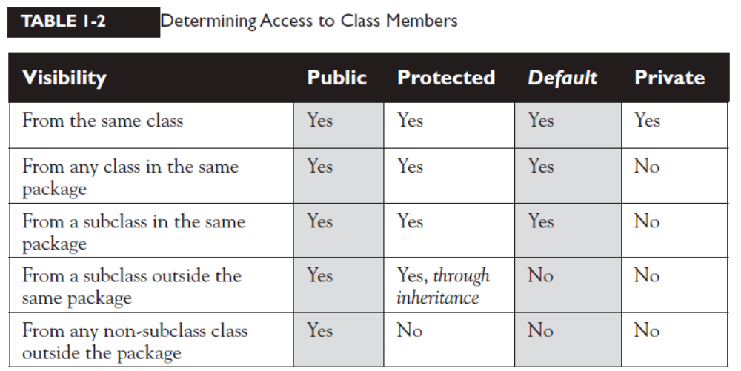
Native Methods

The native modifier indicates that a method is implemented in platform-dependent
Code, often in C

native is a modifier (thus a reserved keyword )
native can be applied only to methods—not classes, not variables, just methods.
Note that a native method's body must be a semicolon (;) (like abstract methods),
indicating that the implementation is omitted.
Variable Argument Lists (var-args)
As of 5.0, Java allows you to create methods that can take a variable number of
Arguments
Arguments The things you specify between the parentheses when you're
Invoking a method:
doStuff("a", 2); // invoking doStuff, so a & 2 are arguments
■ parameters The things in the method's signature that indicate what the
method must receive when it's invoked:
void doStuff(String s, int a) { } // we're expecting two
// parameters: String and int

Var-arg type When you declare a var-arg parameter, you must specify the
type of the argument(s) this parameter of your method can receive. (This can
be a primitive type or an object type.)
■ Basic syntax To declare a method using a var-arg parameter, you follow the
type with an ellipsis (...), a space, and then the name of the array that will
hold the parameters received.
■ Other parameters It's legal to have other parameters in a method that uses
a var-arg.
■ Var-args limits The var-arg must be the last parameter in the method's
signature, and you can have only one var-arg in a method.
Legal:
void doStuff(int... x) { } // expects from 0 to many ints as parameters
void doStuff2(char c, int... x) { } // expects first a char then 0 to many ints
void doStuff3(Animal... animal) { } // 0 to many Animals

Illegal:
void doStuff4(int x...) { } // bad syntax
void doStuff5(int... x, char... y) { } // too many var-args
void doStuff6(String... s, byte b) { } // var-arg must be last

Constructor Declarations

Every time you make a new object, at least one
constructor is invoked.
constructor can't ever, ever, ever, have a return type…ever!

Constructor declarations can however have all of the normal access modifiers, and
they can take arguments (including var-args), just like methods
they must have the same name as the class in which they are declared.
Constructors can't be marked static (they
are after all associated with object instantiation), they can't be marked final
or abstract (because they can't be overridden).

class Foo2 {
// legal constructors
Foo2() { }
private Foo2(byte b) { }
Foo2(int x) { }
Foo2(int x, int... y) { }
// illegal constructors
void Foo2() { } // it's a method, not a constructor
Foo() { } // not a method or a constructor
Foo2(short s); // looks like an abstract method
static Foo2(float f) { } // can't be static
final Foo2(long x) { } // can't be final
abstract Foo2(char c) { } // can't be abstract
Foo2(int... x, int t) { } // bad var-arg syntax
}

Declaring Reference Variables

Object o;
Dog myNewDogReferenceVariable;
String s1, s2, s3; // declare three String vars.

Instance Variables
Instance variables are defined inside the class, but outside of any method, and
are only initialized when the class is instantiated

class Employee {
// define fields (instance variables) for employee instances
private String name;
private String title,
private String manager;
// other code goes here including access methods for private
/
Can use any of the four access levels (which means they can be marked with
any of the three access modifiers)
■ Can be marked final
■ Can be marked transient
■ Cannot be marked abstract
■ Cannot be marked synchronized
■ Cannot be marked strictfp
■ Cannot be marked native
■ Cannot be marked static, because then they'd become class variables

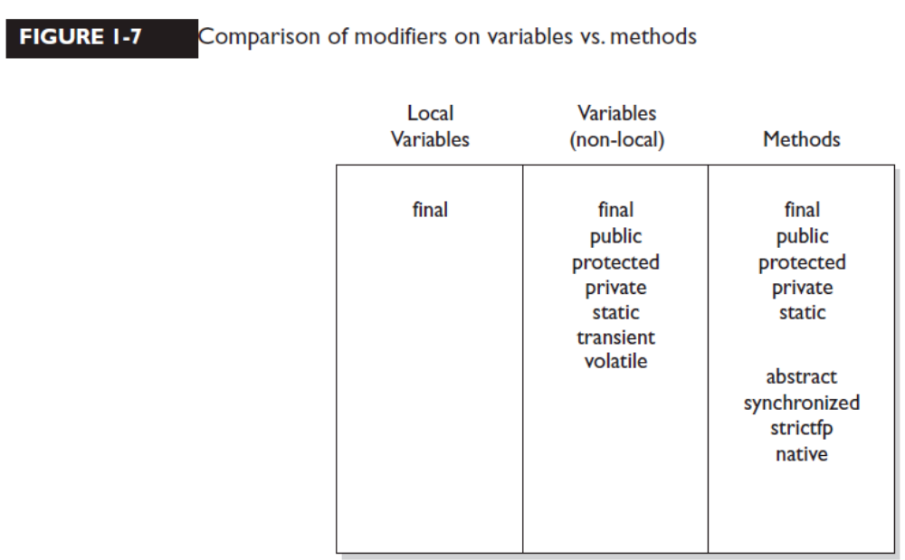
Local (Automatic/Stack/Method) Variables

Local variables are variables declared within a method

local variable starts its life inside the method, it's also destroyed when the
method has completed. Local variables are always on the stack, not the heap

Final Variables
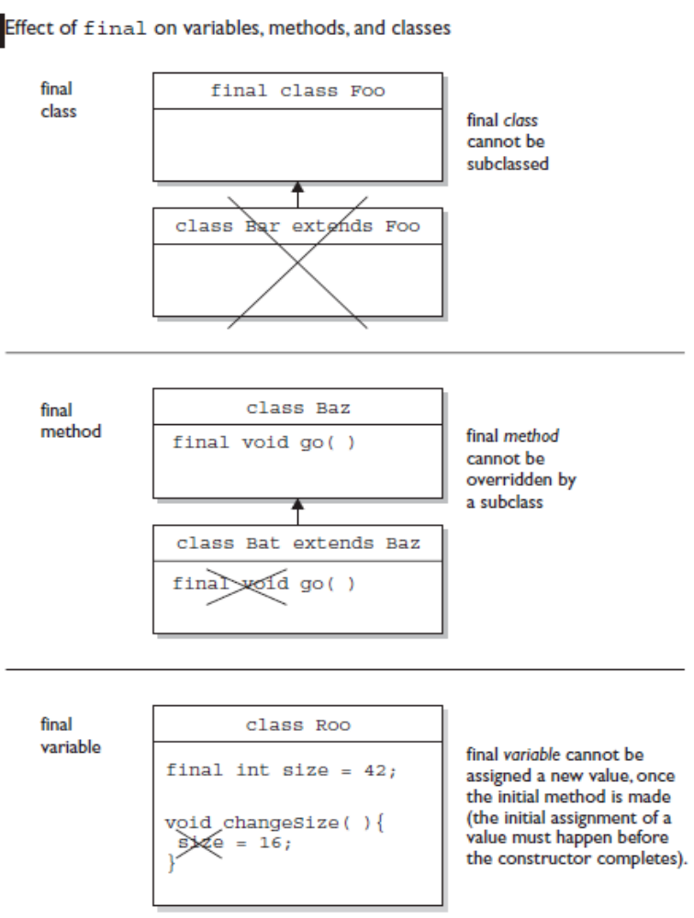
Transient Variables

If you mark an instance variable as transient, you're telling the JVM to skip
(ignore) this variable when you attempt to serialize the object containing it.

Static Variables and Methods
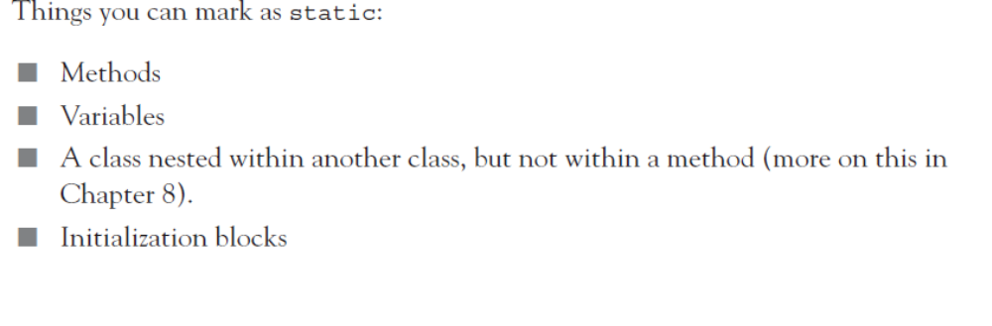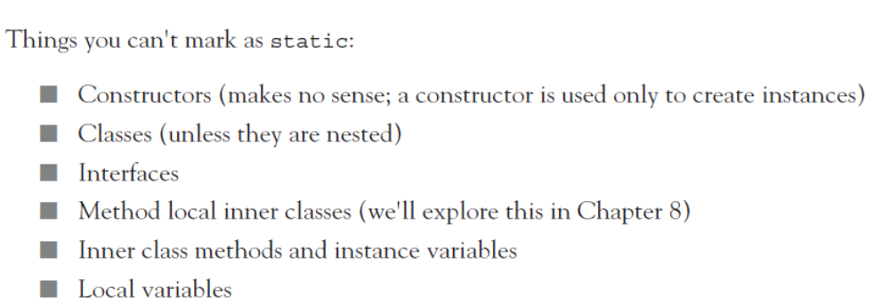
Declaring Enums
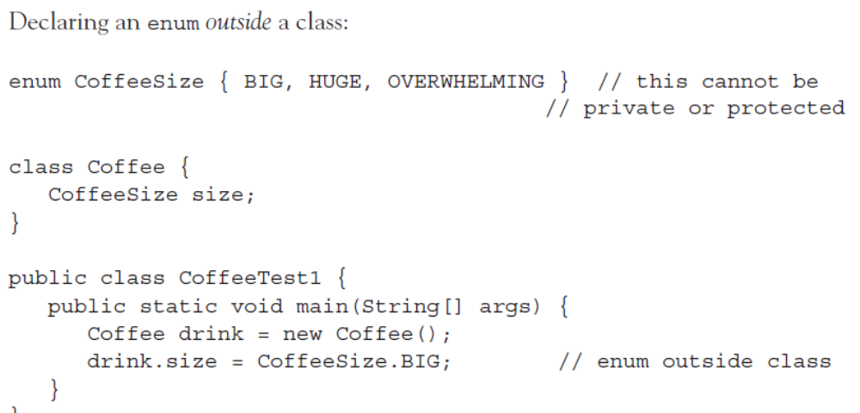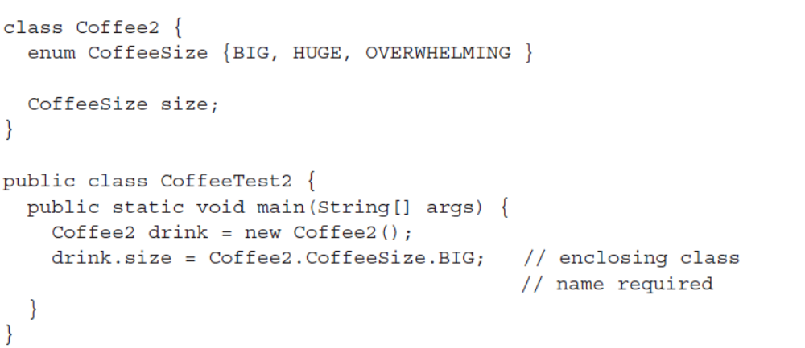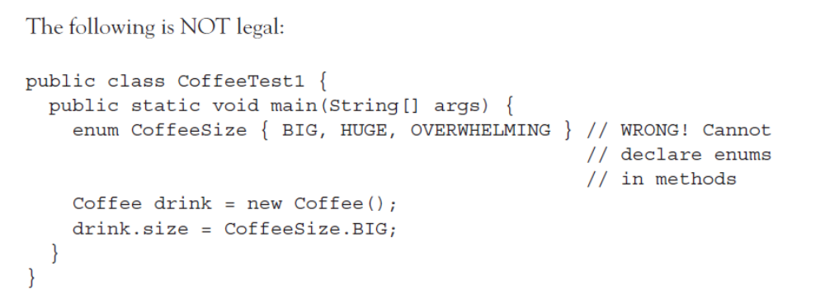

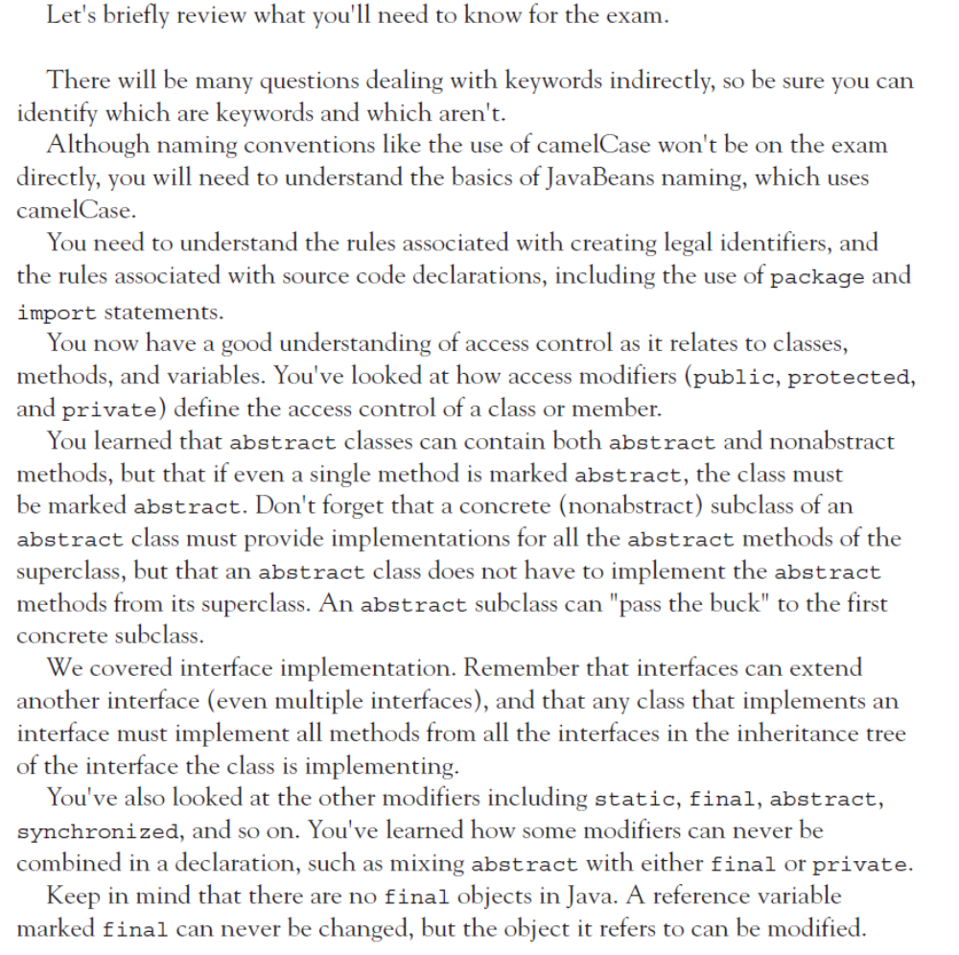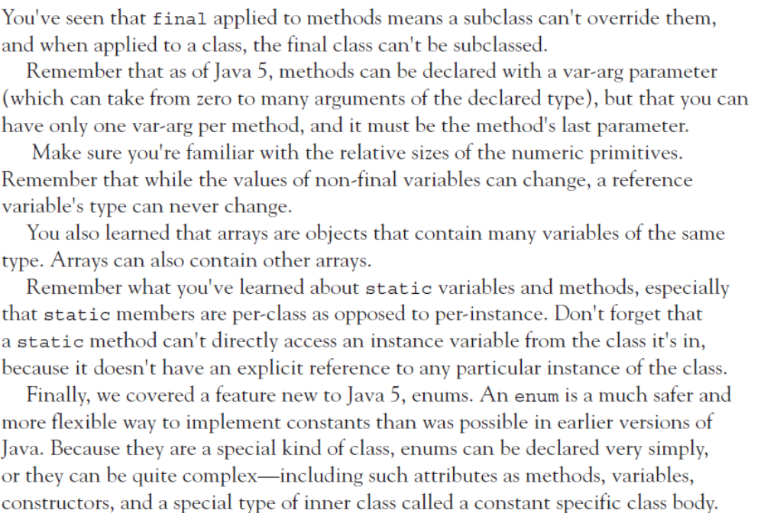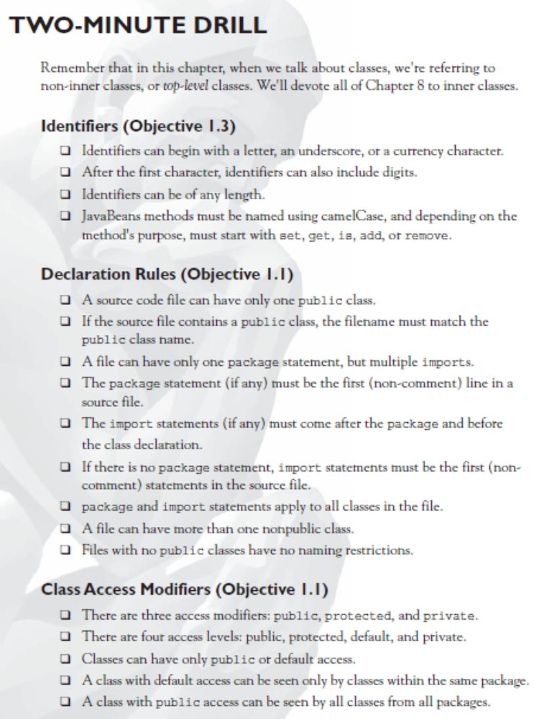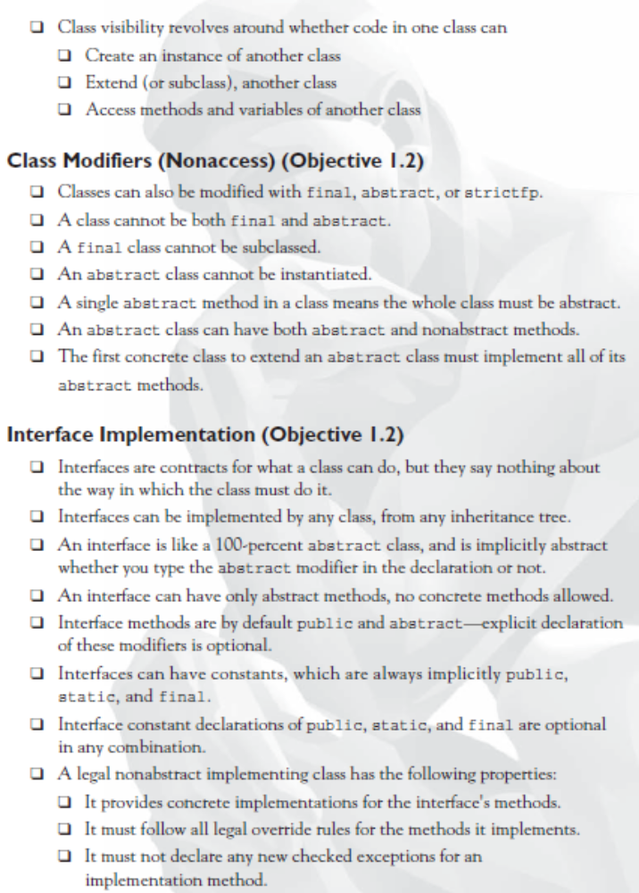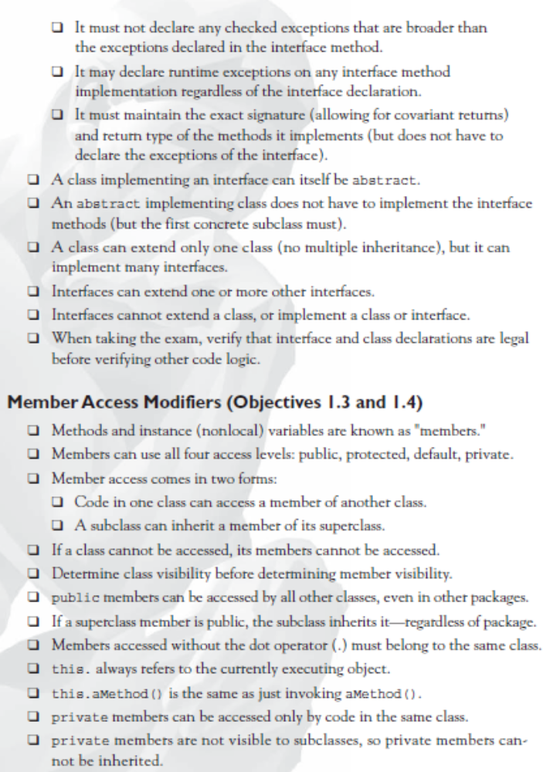
CHAPTER-2
Object Orientation

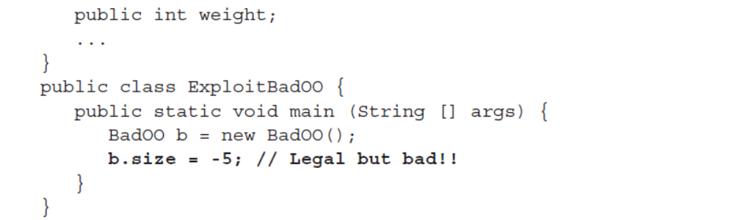
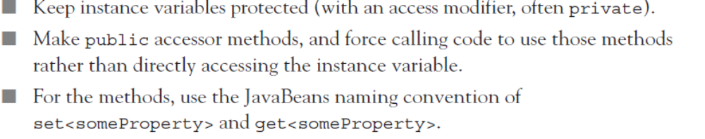

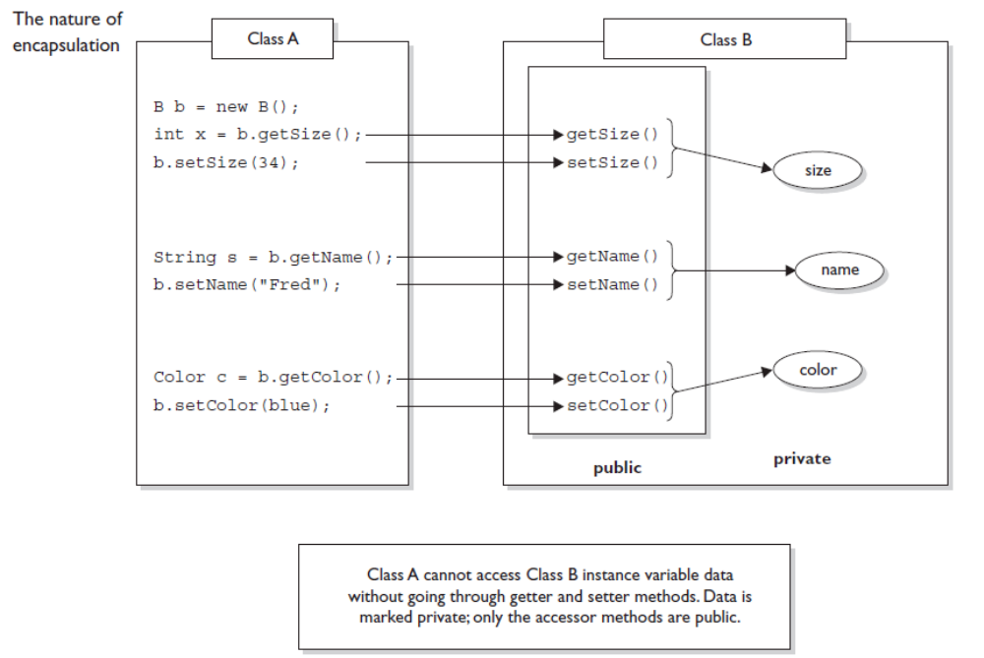
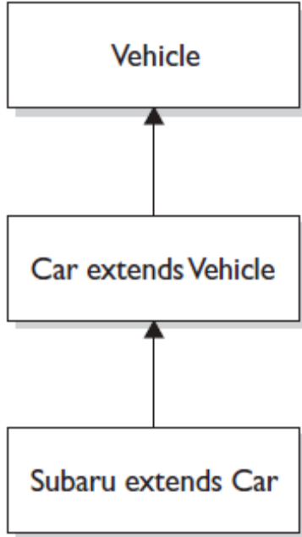


Any time you have a class that inherits a method from a superclass, you have the
opportunity to override the method (unless, as you learned earlier, the method is
marked final).
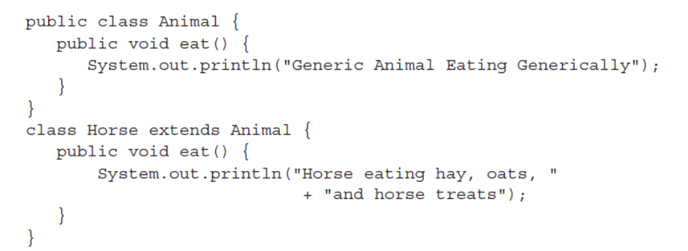
concrete subclass overrides the abstract methods of the superclass. So you
could think of abstract methods as methods you're forced to override.
